January 14, 2026

Bid No. 7195.5, Computer Supplies

Contract Amendment Number 2

In accordance with the terms of the above-mentioned contract, this is authorization to extend this contract
for one year through January 16, 2027.

REMARKS: Please see attached summary of contracts for pricing and supplier information

COMMENTS: This is the first of four options to extend.

REFER QUESTIONS TO: Saudy Espinal, Buyer II, 240-740-7537, saudy_espinaldeveloz@mcpsmd.org

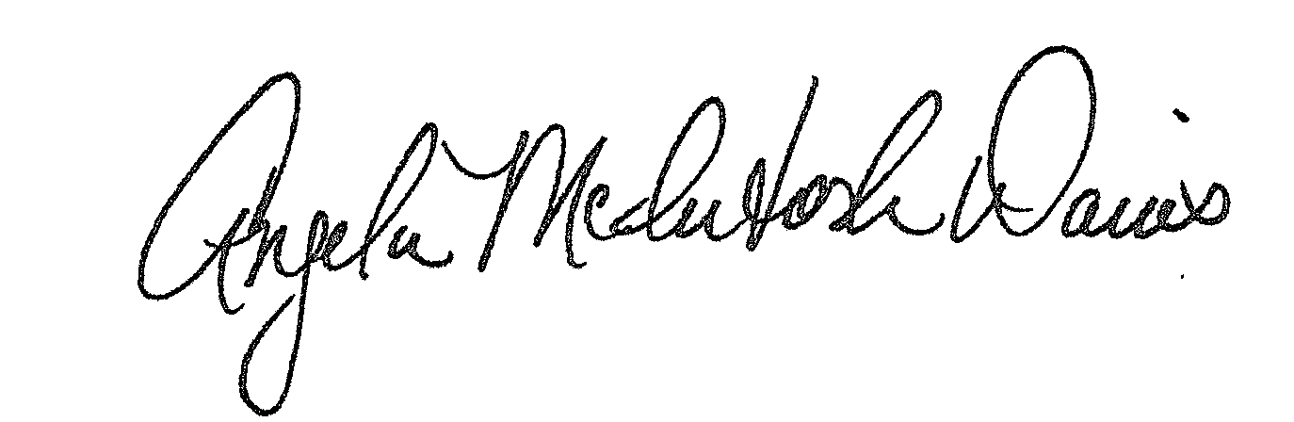

Approved:
Angela McIntosh-Davis, CPPB, Director, Department of Procurement.

AMD:se

Distribution: Supplier(s);
Bid File

